**DECIMAL TO OCTAL CONVERSION**

**EXP NO: 23**

**AIM:** To write a C program to implement decimal to octal conversion.

**ALGORITHM:**

1. Store the remainder when the number is divided by 8 in an array.
2. Divide the number by 8 now
3. Repeat the above two steps until the number is not equal to 0.
4. Print the array in reverse order now.

**PROGRAM:**

#include <stdio.h> int main()

{

long decimal, remainder, quotient,octal=0; int octalnum[100], i = 1, j; printf("Enter the decimal number: "); scanf("%ld", &decimal); quotient = decimal; while (quotient != 0)

{

octalnum[i++] = quotient % 8; quotient = quotient / 8;

}

for (j = i - 1; j > 0; j--) octal= octal*10 + octalnum[j]; printf("Equivalent octal value of decimal no %d is: %d ", decimal,octalnum); return 0;

}

**INPUT:**

**25**

**OUTPUT:**

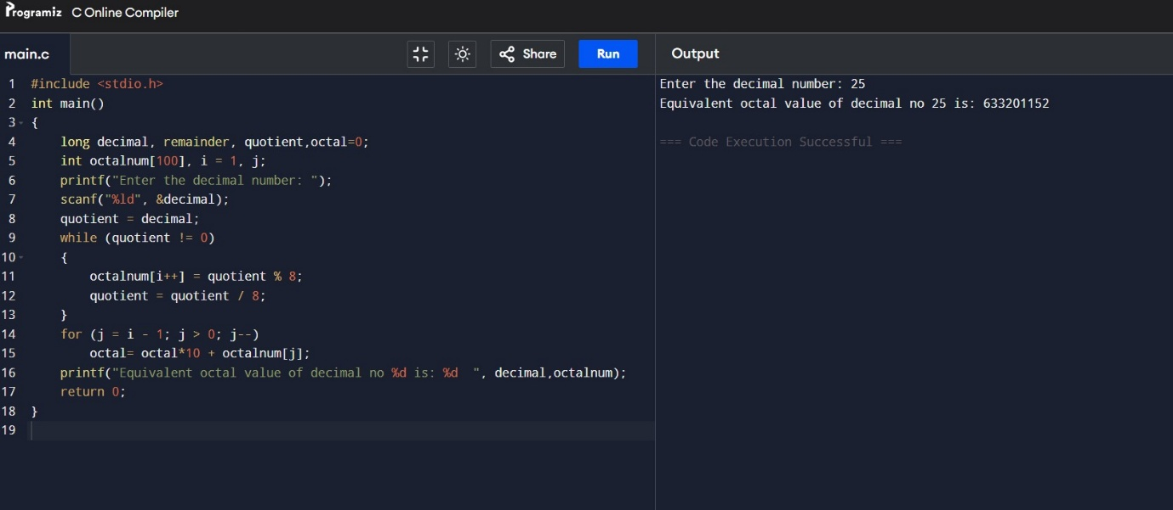

**RESULT:** Thus the program was executed successfully using DevC++.